 | Abdi İpekçi Caddesi Kaşıkçıoğlu Apt. No:42 D:2 34365 Nişantaşı İstanbul  www.artxist.com  info@artxist.com  T. +90 212 291 77 84 F. +90 212 343 69 35 | BASIN BÜLTENİ

Ali Elmacı’s solo show titled "Kill Him, Make Me Laugh" is taking place at x-ist between 20 November and 20 December 2014.

ALİ ELMACI | Kill Him, Make Me Laugh

In order to understand why Ali Elmacı's figures stare into our eyes and solve the puzzles in his works, one must first take a look at his previous body of work. "Inheritance Passes From Father To Son", his first solo show at x-ist in 2011, questioned the primary means of security and trust in our day, which are family and money. In his next show, "Save Me With Your Fire" (2012), Elmacı shifted his focus from personal to societal, and dealt with the dynamics among the individual, the state and the media, claiming that societies are manipulated by fear. Finally, in his new show "Kill Him, Make Me Laugh", Elmacı creates a link between the personal and the societal by taking in hand the government's educational policies and how it shapes the new generation. With the use of symbols and fantastic characters, Elmacı emphasizes the gap between the presented images and the actual truth.

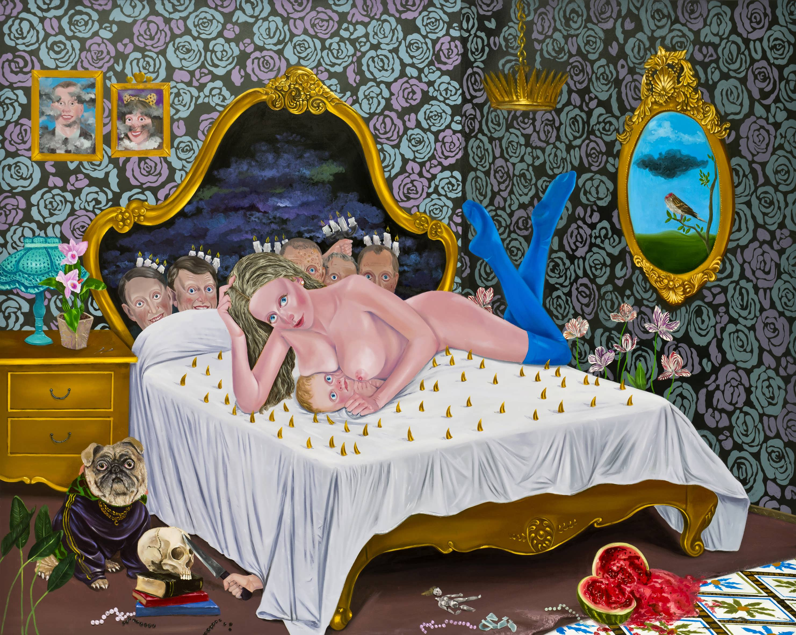
Ali Elmacı, “Kill Him, Make Me Laugh”, Oil on canvas, 175 x 220 cm, 2014

"Kill Him, Make Me Laugh" is full of wasps making honey, skulls stuck to an abacus, turbans in the form of intestines and nervous children staring at the viewer. The dualities such as, the attractive and the repellent, the intimate and the menacing, the natural and the artificial, the divine and the kitsch, make us question what to believe. According to Elmacı, the images presented in the media are put together with collage and fiction, just like these paintings.

The stories constructed with manipulation of the truth and garnished with symbols of power and security, are presented to us with elegance. Elmacı believes that every government first intervenes in the educational system, in order to mandate policies through it. As the title suggests, partisanship becomes the only way to survival, rather than a free choice.
The sequins we see in "Inheritance Passes From Father To Son" and the camouflage pattern in "Save Me With Your Fire" transform into fake backgrounds and gold-coated ornaments. Symbolic scenarios representing either state terrorism or wealth, warn against the possible threatening consequences of disobeying the authorities. Innocent-looking characters and kitsch backgrounds of Elmacı play on the perceptions of the viewer.
“Kill Him, Make Me Laugh”, consisting of Elmacı's new canvases, drawings, and one sculpture, and can be seen till the 20th of December at x-ist.
For more information please contact Ece Göymen from x-ist.
E. ece@artxist.com
T. +90 212 291 77 84

ALİ ELMACI | Sinop, 1976
Elmacı graduated from Mimar Sinan Fine Arts Faculty, Painting Department in 2010. He had two solo shows at x-ist, titled “Inheritance Passes From Father to Son” (2011) and “Save Me With Your Fire” (2012)..He has also been taking place in several group exhibitions since 2007. Among the exhibitions and fairs Elmacı participated are “Art Against Invasion” (Karşı Sanat, 2007), “My Name is Casper” (Old Sümerbank Building, 2009), Contemporary Istanbul’10, 11, 12 & 13, “Genç Ustalar, Usta Gençler” (MKM, 2010), Art Beat 2011 (Istanbul), Art Dubai 2012,and Scope Basel 2012 and Art14London.

